Design Document

By: Sarah Klingbeil

1. **Goals**

Mission statement

This web is committed to providing a place where people can pray together, get comfort, and grow spiritually, by helping and inspiring us all to know God better.

Goals

I want to make a website, where people can find comfort and hope, grow spiritually and know God better.

**2. User Experience**

2.1 Audience Definition

Anyone who wants to find comfort and hope through prayer.

2.2 Scenarios

Sue's in 10th grade in high school in California. Sue is having a rough time, her parents had just been divorced. She feels hurt and alone. She wants to find comfort, she wants to find hope. She types in comfort and hope and finds a website that sends comforting, and hopeful Bible texts. She also sees that you can send in prayer requests and she types in hers. She clicks on the stories and sees how other people had faced what she is facing and feels comforted.

Jack is 35, married, and likes his job as a high school math teacher in Ohio. He thinks he's happy and doesn't need anything. Then one day, he's mother suddenly dies of a heart attack. He's really sad. He wants to find comfort and he wants to find hope. He remembers a friend telling him about a web site where he found comfort. He types it in and sees the prayer request and types his in. He reads the stories and loves the colorful Bible texts which he sends to some of his family.

Jenny is 15 and a 9th grader, and has just moved to a new town in Washington State. She feels alone and scare. She wants to find comfort and support. She types in the words support and comfort and finds a web. She sees that you can send in your prayer requests and types in hers. She enjoys stories and worship thoughts. She also likes the nicely designed Bible texts. And starts to feel hope rise in her.

2.3 Competitive Analysis Summary

Many of the other web sites didn’t have the prayer requests as their main mission. Some were crowded and looked confusing, But none made it easy to submit a prayer request. I liked some that looked neat and easy to use…

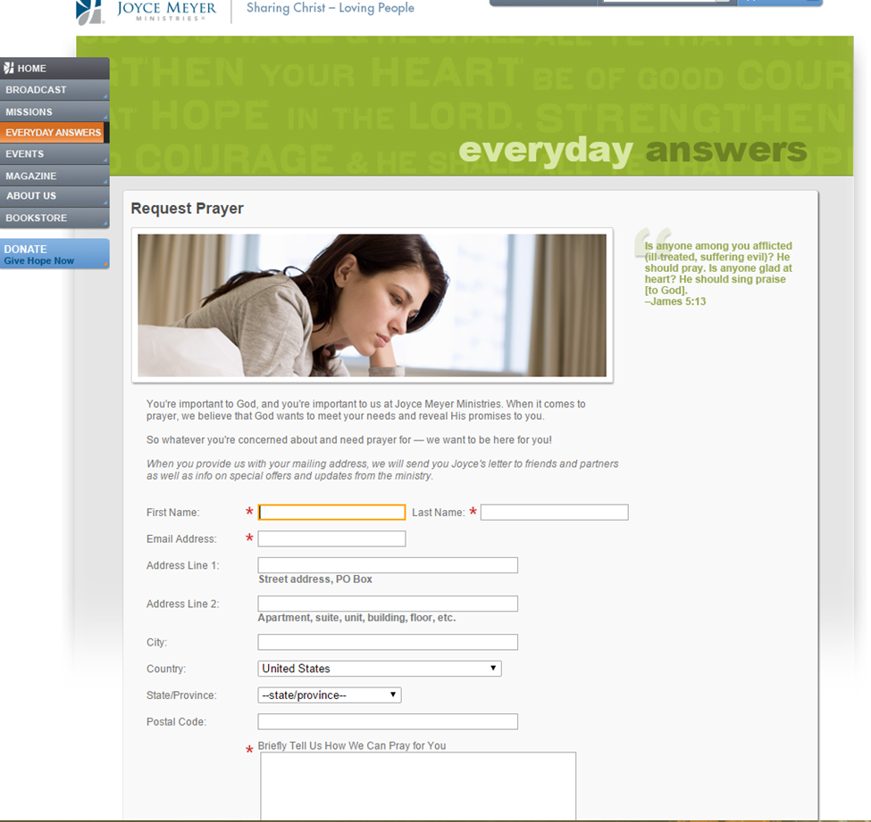

http://www.joycemeyer.org/EverydayAnswers/RequestPrayer.aspx

Pros: neat, simple looking

Cons: It looks really official, and you have to give a lot of info to submit prayer request

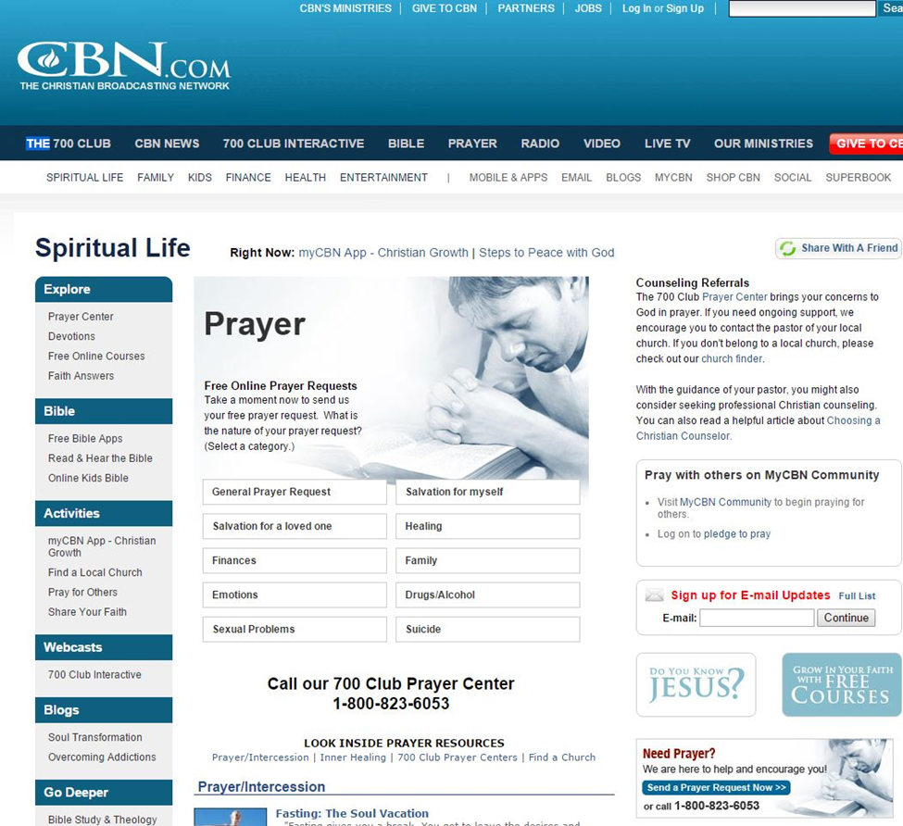

http://www.cbn.com/spirituallife/PrayerAndCounseling/index.aspx

Pros: it's clear about its message

Cons: It's crowded, the prayer requests is not the main goal of the web site

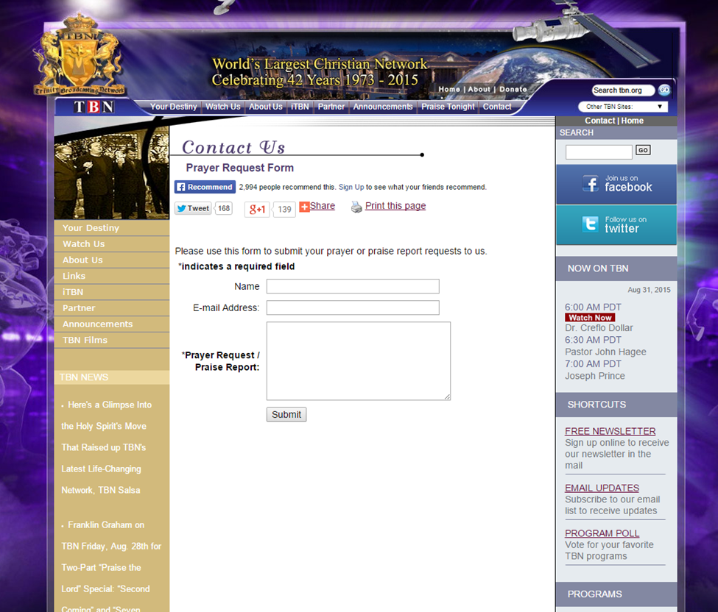

http://www.tbn.org/contact/prayer-request-form

pros: that they have the idea

cons: It to confusing and the prayer requests is not main goal. I think the background isn’t good.

**3. Site Content**

3.1 Content Grouping and Labeling

Content elements:

mission statement

blog page

 Copyright notice

Privacy statements

Members’ login pages; sign up pages

Membership rules

Weekly newsletter

Stories pages

A system that sends prayer request first to me before posting it.

Something like a like button, but says I prayed for this person.

Bible text gallery

A way to send it to people (bible texts)

Feedback: They liked it.

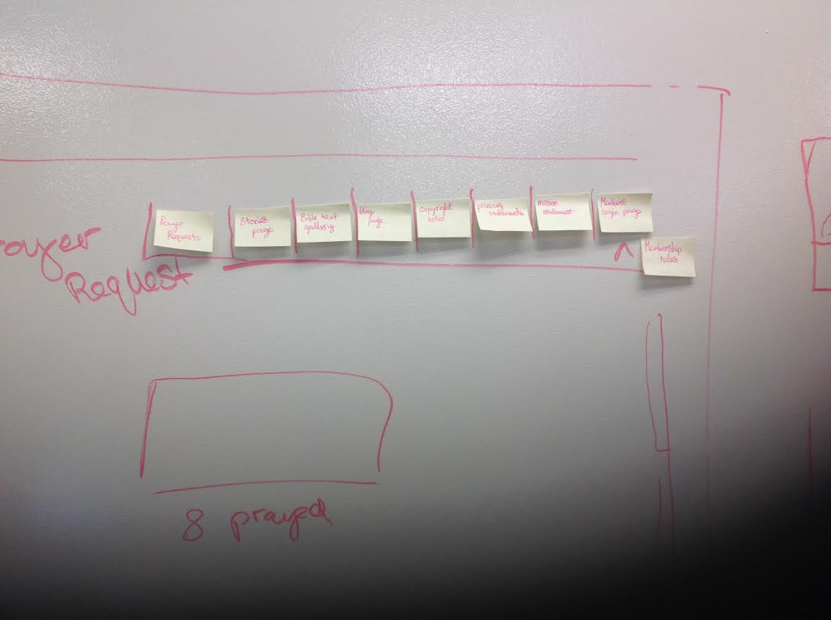

3.2 Functional Requirements

**4. Site Structure**

4.1 Metaphors (or summary)

Telephone- A telephone connects people to talk with one another. My web connects people to pray with each other. The buttons are like the tabs in my web.

4.2 Site Structure

1. Homepage
   1. Prayer requests
      1. Submit page
      2. Prayer for page
   2. Bible Text gallery
      1. Bible texts
      2. A way to email them
   3. Stories/devotionals
      1. Devotionals
         1. Kids
         2. Adults
      2. Stories
         1. Kids
         2. Adults

4.3 Global and Local Navigation Systems

Navigation

Stories/devotionals

Bible Text gallery

Prayer Requests

**5. Visual Design**

5.1 Layout Grids

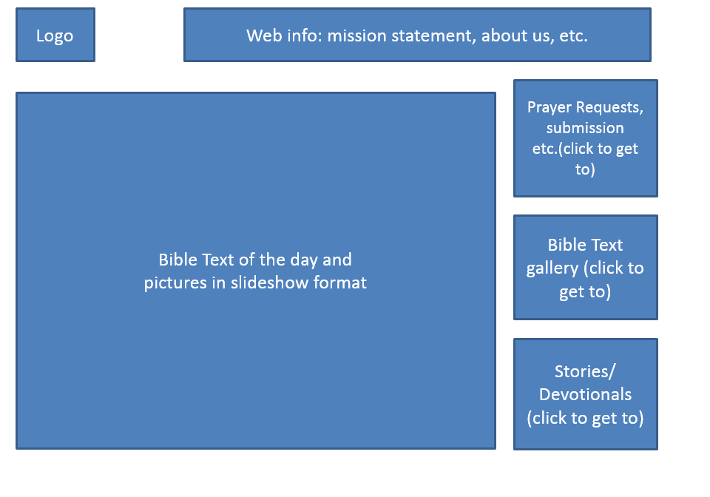

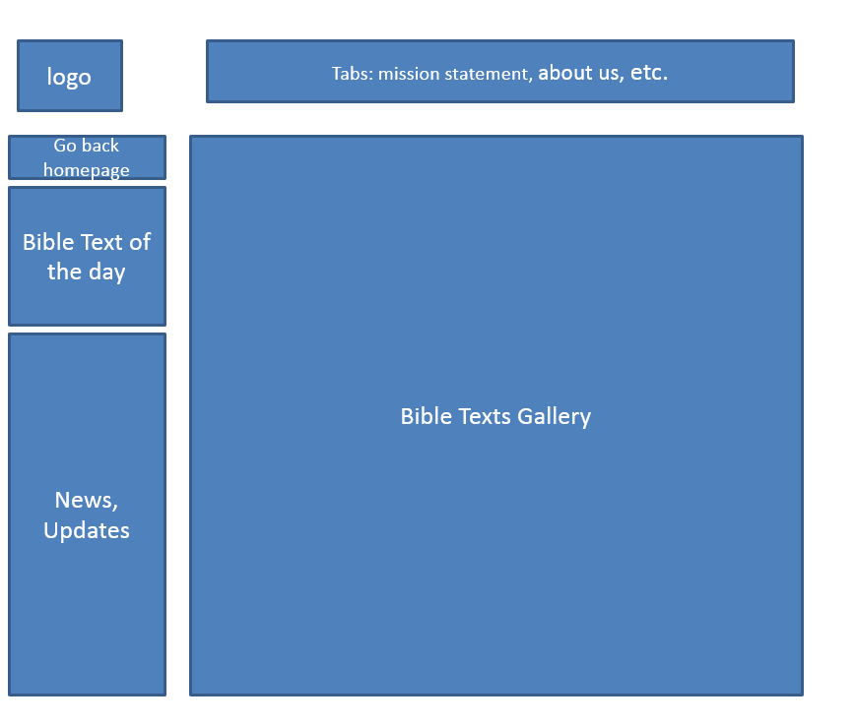

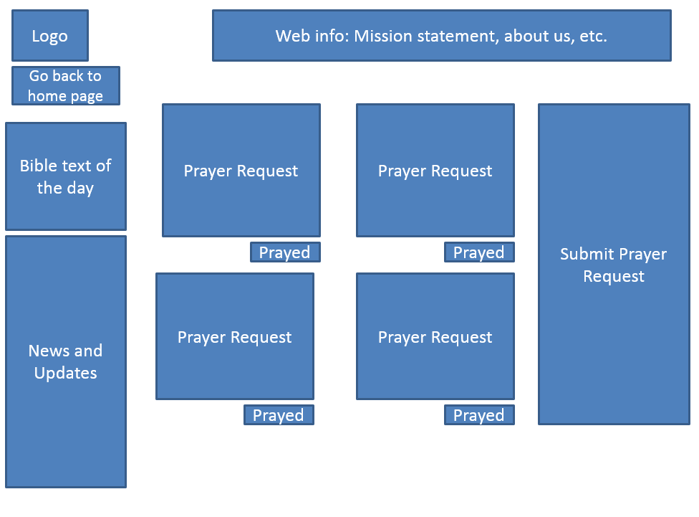

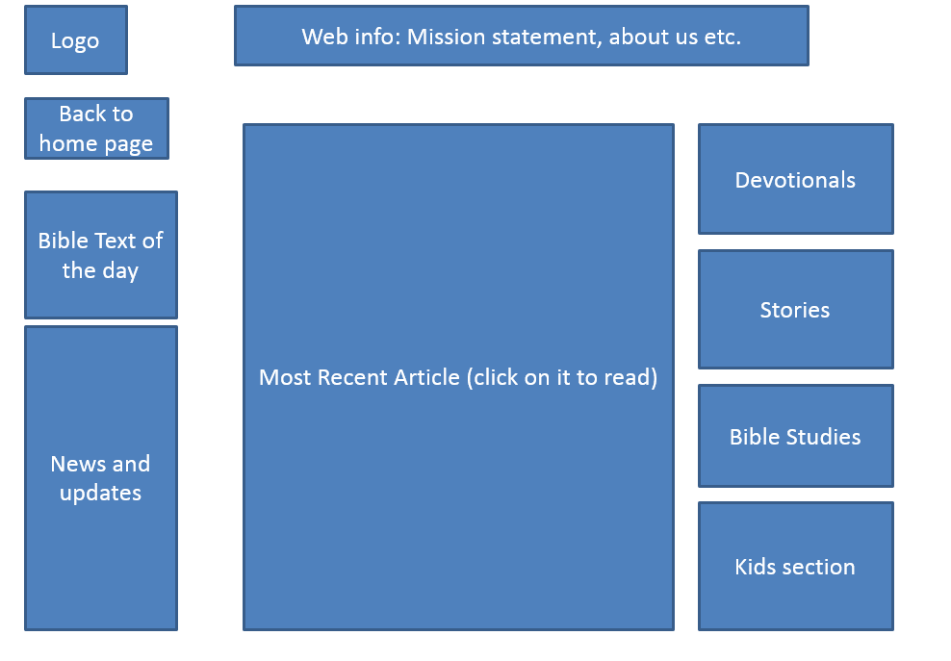

5.2 Mood Boards



5.3 Page Mock-ups

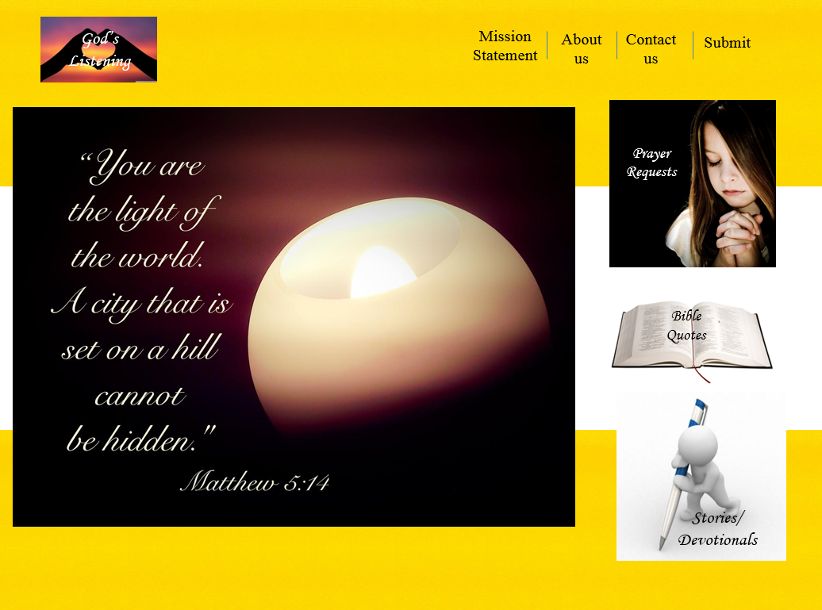

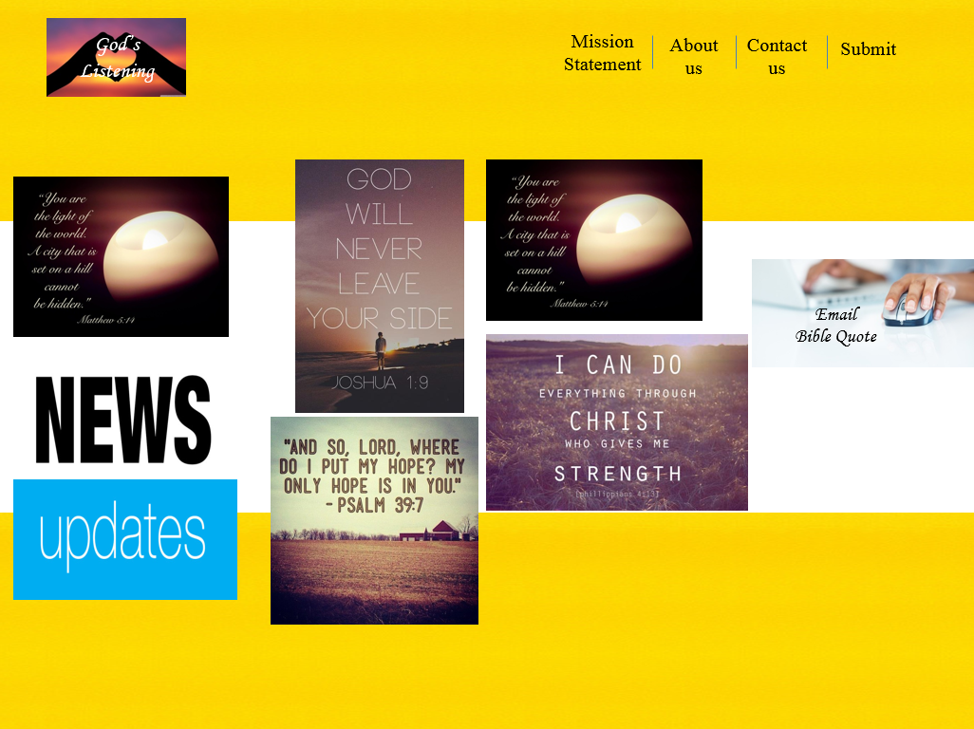

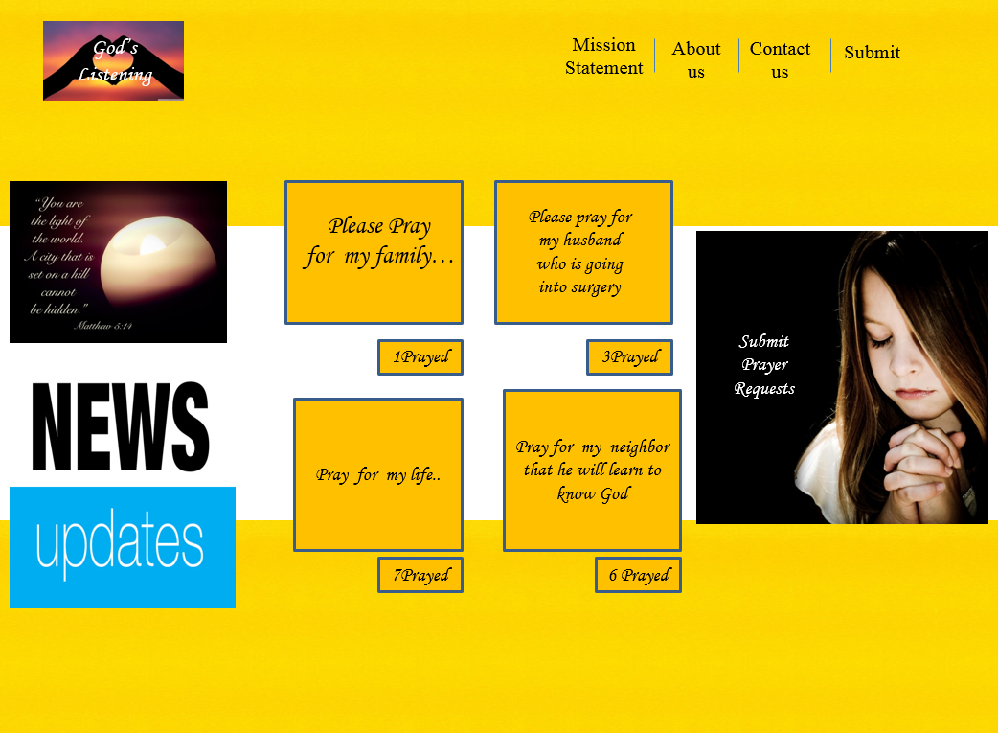

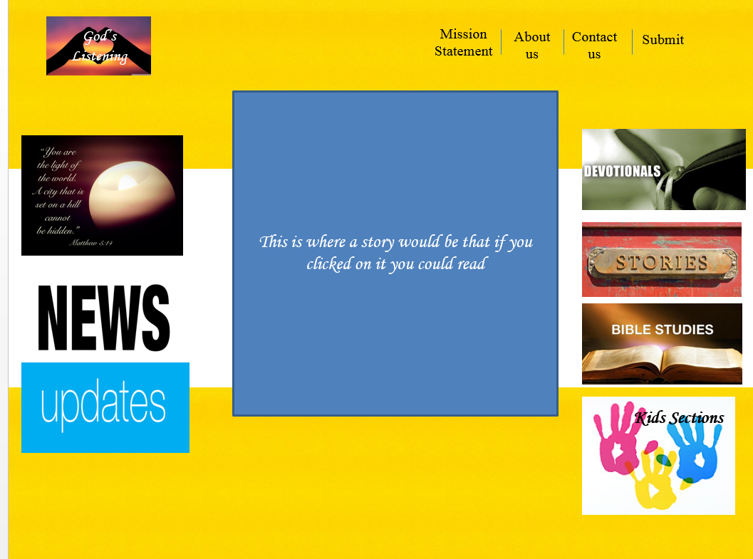

**Appendix A:** Competitive Analysis

**Appendix B:** Content Inventory

**Appendix C:** Site Structure Listing (optional)